**Instructions For iOS Phone Verification**

1. Add the NetworkingLogic folder, which contains six files, to the project folder, as shown in *Figure 1*.

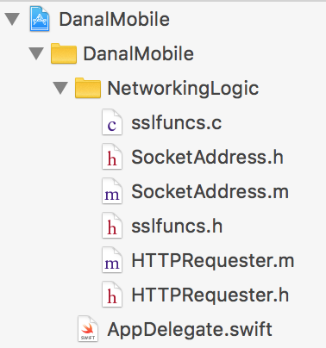

***Figure 1***

1. Include #import "HTTPRequester.h" in the Swift bridging header file, as shown in Figure 2.

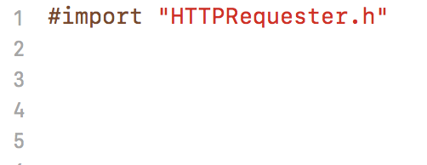

***Figure 2***

1. Include func fireURL(url:String) -> String as a member function in the View Controller that fires the EVURL. The function definition is located in FireURL.swift
2. 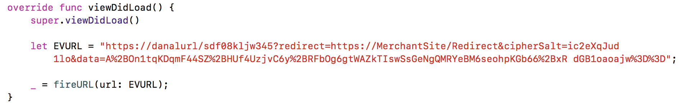Fire the EVURL as shown in *Figure 3*. An EVURL should be passed for the ‘url’ parameter.

***Figure 3***